Use-Case Realization Report (Analysis)
Login

Issue <1.0>
Revision History
Date | Issue | Description | Author
<29/Jul/11> | <1.0> | Initial Document | Koh Ming Jin

Table of Contents
1. Brief Description 4
2. Flow of Events 4
2.1 Standard Flow 4
2.2 Exception 4
3. Interaction Diagrams 4
3.1 Collaboration Diagram for System Login 4
4. Participating Objects 5
4.1 Main Page 5
4.2 Role Main Page 5
4.3 Security Controller 5
4.4 Role 5
4.5 Employee 5
5. Class Diagrams 5
5.1 Domain Class Diagram: View Login 5
6. Derived Requirements 5

Use-Case Realization Report
View Login

Brief Description
This use case enables an employee to log in into the system.

Flow of Events
The standard flow of events for this use case and any exceptions are described in the following subsections. See section 3.1 for an overview of the participating Actors and Domain Objects.

Standard Flow
The flow of events is described as follows:

- The use case starts when an employee selects the Login option of the system.
- The Login Page, which includes the employee ID and password, will be displayed.
- The employee will input the required information and press login.
- The system will verify the input information with the backend data.
- If the employee ID and password matches, it will redirect the employee to his or her role’s main page
- The use case terminates.

Exception
- Authentication fails. If the employee’s input information do not match with the existing credentials, an error message will be displayed and the employee will be redirected to the login page again.

Interaction Diagrams

Collaboration Diagram for System Login
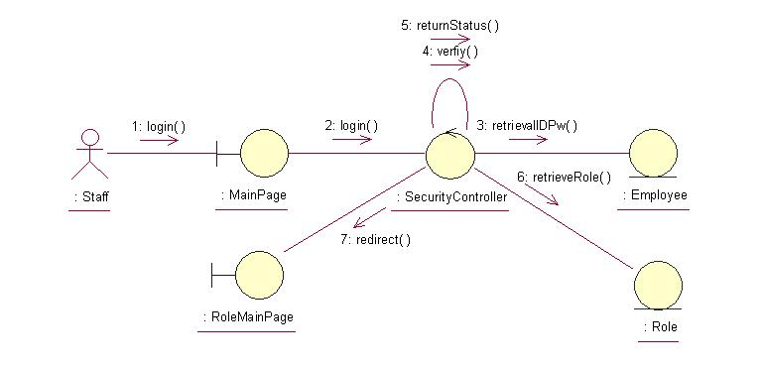

Participating Objects

Main Page
This object renders the contents to allow actors to login into the system. All actors use this object.

Role Main Page
This object renders the contents to allow the authorized Sales staff actor to perform his or her jobs.

Security Controller
This object acts as the middleman between Main Pages and the Employee and Role objects. It will translate interactions with the view into actions to be performed by the Employee and Role objects.

Role
This object stores the details concerning the Role of the COMS.

Employee
This object stores the details concerning the Employee of the COMS.

Class Diagrams

Domain Class Diagram: View Login
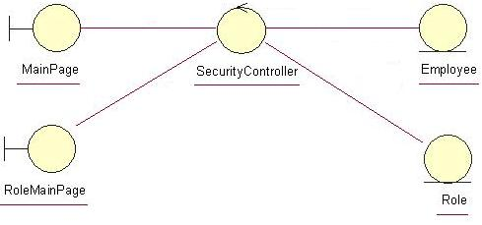

Derived Requirements
The Employee barcode scanner or PC keyboard and mouse will be used to login into the system (if any) and view all the system responses.

